**Tell me about yourself?**

My story is a little different. I hope you find it interesting as I go through. Start with childhood

**Systems Analysis**

Process of understanding in detail **what** a system should accomplish

**Systems Analyst- or a problem solver**

Uses analysis and design techniques to solve business problems using information technology

The **analyst** interacts with the **business** stakeholders and subject matter experts to understand their problems and needs.

They bring business and information technology (IT) together by understanding the needs and limitations of both.

The ultimate goal is help in **making recommendations that help the organization advance financially or have an edge over competitors.**

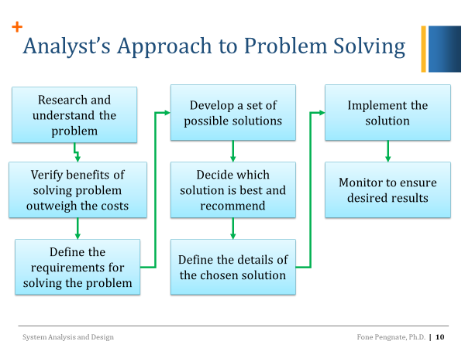

* The ***systems development life cycle*** *(SDLC)* is the process of determining how an information system (IS) can support business needs, designing the system, building it, and delivering it to users
* 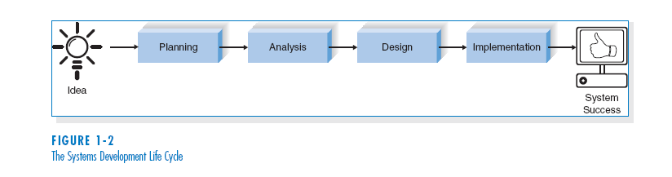The key person in the SDLC is the *systems analyst (SA)*, who analyzes the business situation, identifies the opportunities for improvements, and designs an IS to implement the improvements

**Skills**

* Strong problem-solving
* Analytical skills
* communication and interpersonal skills,

**Functional VS non-Functional Requirements**

non-functional requirements describe how the system works, while functional requirements describe what the system should do. The functional requirement is describing the behavior of the system as it relates to the system’s functionality. The non-functional requirement elaborates a performance characteristic of the system.

|  |  |
| --- | --- |
| Functional Req | Non Functional Req |
| * Business Rules. * Transaction corrections, adjustments and cancellations. * Administrative functions. * Authentication * Audit Tracking | * Performance. for example, Response Time, Throughput, Utilization, * Scalability. * Capacity. * Availability. * Reliability. |

|  |
| --- |
| ***Agile Project Management***   * *Heavily involve the users in the project* rather than have them to simply sign off on specification * Includes face-to-face communication * Extreme programming (XP) – Emphasizes customer satisfaction and teamwork * SCRUM – Combination of rugby and agile |

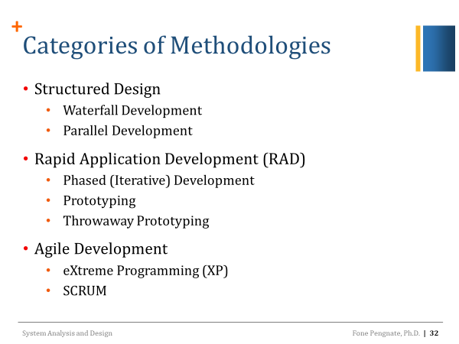

|  |
| --- |
| **Scrum Methodology**   * Combination of principles of rugby and agile   Begins quickly, is a very intense effort of the entire team, and usually lasts for a (short) defined period of time   * SCRUM project is a list of all the things the system should include and address—called *product backlog* * **The product backlog includes**   + User functions (e.g., use cases)   + Features (e.g., security)   + Technology (e.g., platforms * Product owner; The client stakeholder who controls backlog * SCRUM master   SCRUM project manager who enforces SCRUM practices and helps the team complete its work   * SCRUM team   Small group of developers (5-9 people) |

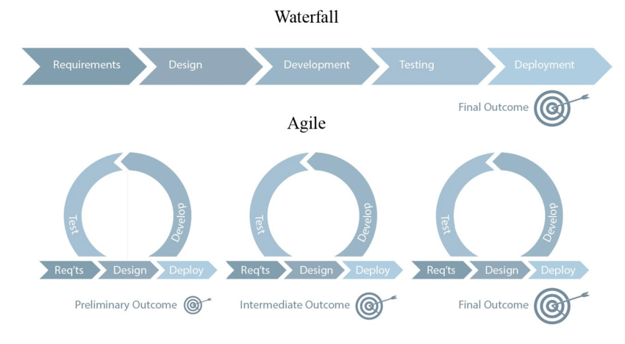 **Agile Project Management** (APM) is an iterative approach to planning and guiding **project** processes. **Agile project** is completed in small sections, called **iterations**.

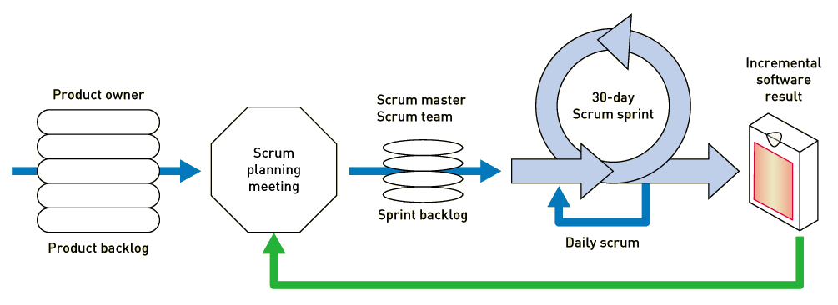

1. **System Request**: project sponsor, business need, business requirements, special issue
2. **Requirements Determination**: based on the system request
   1. **Business Requirements**
   2. **User requirements**
   3. **Functional Requirements –** functions that the systems has to perform**.** **Nonfunctional requirements *characteristics* of the system other than activities it must perform or support.**

**Business Process Improvement** BPI makes *moderate* changes to the way in which the organization operates to take advantage of new opportunities.

**Business Process Reengineering (**BPR) changes the *fundamental* way in which the organization operates

**Business Process Automation** - BPA leaves the basic way in which the organization operates unchanged and uses computer technology to do some of the work

1. **System Proposal** – combines all materials created in planning and analysis

Now the process of turning requirements into functions.

**Develop *use-cases* from the requirements**

* + **Use-case**: how a business system interacts with its environment. A diagram and a description of activities.
  + A Business Use-Case is how a customer can make use of the business
  + a System Use-Case is how a user of a computer system can make use of the system to get the result they want.

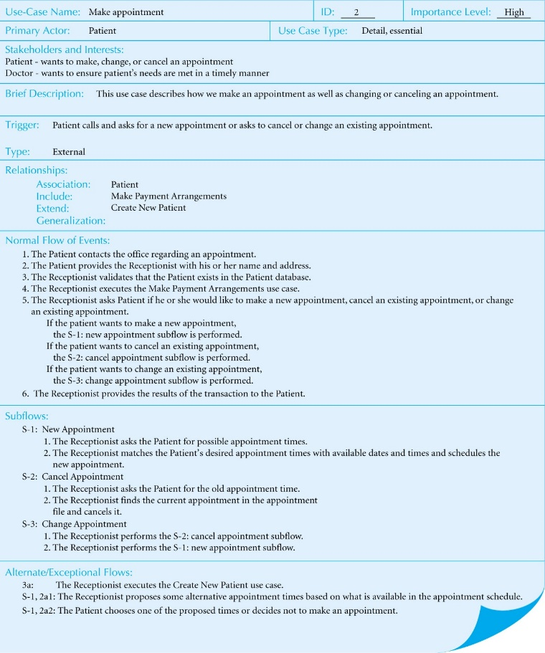



Use case Diagram Syntax:

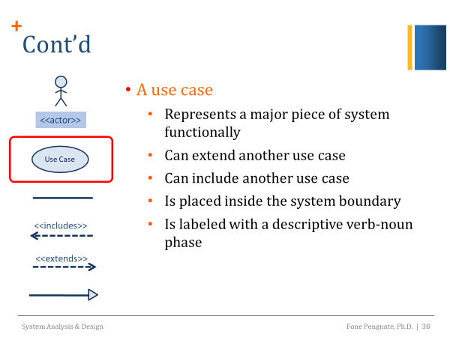

Steps for Writings-Case Description and Diagrams

* Identifying the major use cases
* Expand the major use cases
* Confirm the major use cases
* Create the use-case diagram

**Developed an activity diagrams from the us-cases**

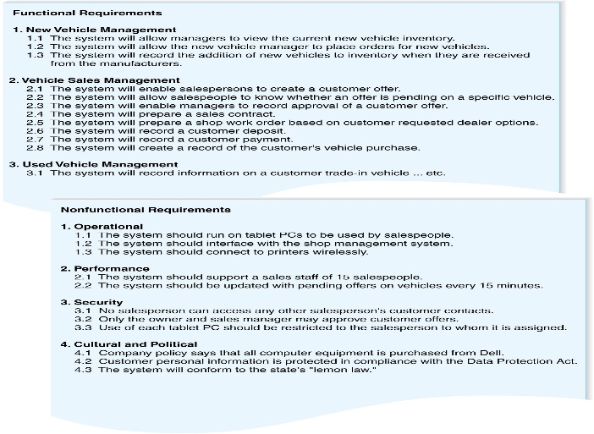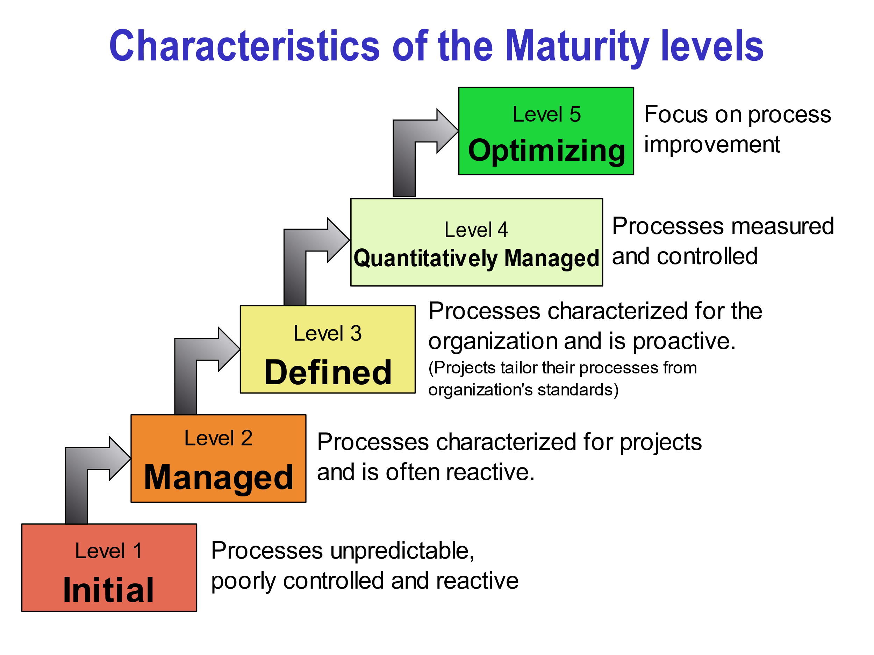

**Capability Maturity Model Integration CMMI** used to guide process improvement across a project, division, or an entire organization. CMMI defines the following maturity levels for processes:

Initial, Managed, Defined, Quantitatively Managed, and Optimizing.

**CA Clarity** is a Project and Portfolio management (PPM) platform that helps businesses effectively and efficiently manage their products, services, peoples, and finances into a more centralized setup. It is like Microsoft project.

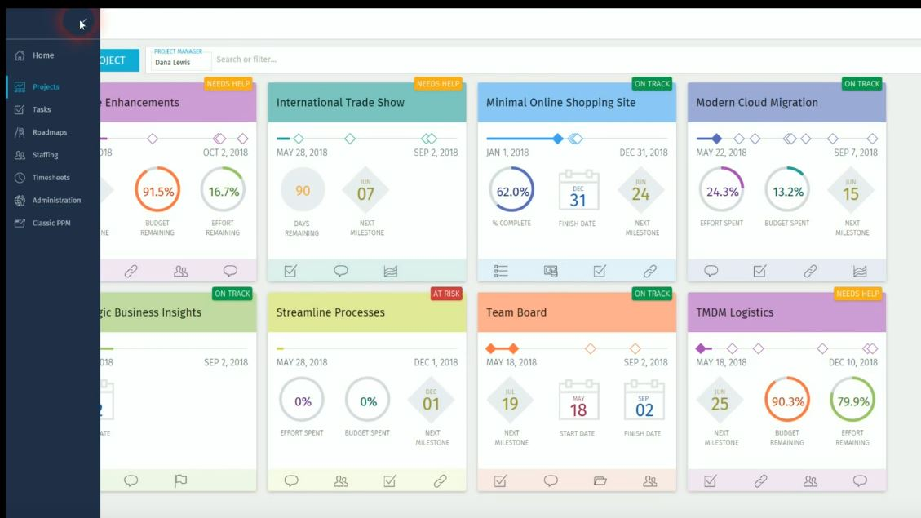

You can create new project, you can do staffing-timesheets, financial plans, you can add people, tasks, activities, generate reports, chats, creating links, do risk management, issues, changes, documents (can be stored all in one place), details, you can add custom attributes and defaults, and so on. Blueprints: change the project looks and how it displays. Add remove attributes. It is your project view. Roadmap approach focus on top down approach of planning. Visual light plan. Resourcing and timesheets; in the staffing screen. You can submit or edit your timesheets.

**Test case: (step** details, expected results, actual results, pass/ failed/not expect or suspended**)**

**Business process modeling**; Gant charts. It is graphical representation of a company's **business processes** or workflows, as a means of identifying potential improvements. Use this to current process may be analyzed, improved, and automated. To reduce time, cost, to increase quality. **Techniques**: flow charts, control flow charts, PERT diagram, and Gant charts.

**HP Quality Center; s**oftware quality management product. It is a web-based tool Quality Center includes components for requirements management, quality planning, [software testing](https://whatis.techtarget.com/definition/software-testing) management, [business process](https://searchcio.techtarget.com/definition/business-process) testing, defect management and [release](https://searchitchannel.techtarget.com/definition/release-management) and cycle management.

My strength is that I'm a hard worker. I believe in working hard. Nothing replaces hard work. I usually work beyond my shift. My job matters a lot to me.

I am an honest person. If I don’t know something, I will not pretend that I know it. I am not afraid of saying I don’t know.

My weakness is that I get stressed when I miss a deadline because someone else dropped the ball.

I don’t sit around and waiting for instructions. I step up to improve things. That is what I believe I am good at.

I gather requirements. What the business needs and translate those into system requirements which are documented. And translate those over to IT department developers and testers to build these requirements and applications. Its interacting between the IT and Business departments.

This requires analytical skills. Digging into systems and software figuring out what can be done what can’t be done. Here are the business requirements, here is the system requirements. How we really do that and deliver that.